Azure Spot Virtual Machines for InterruptibleWorkloads

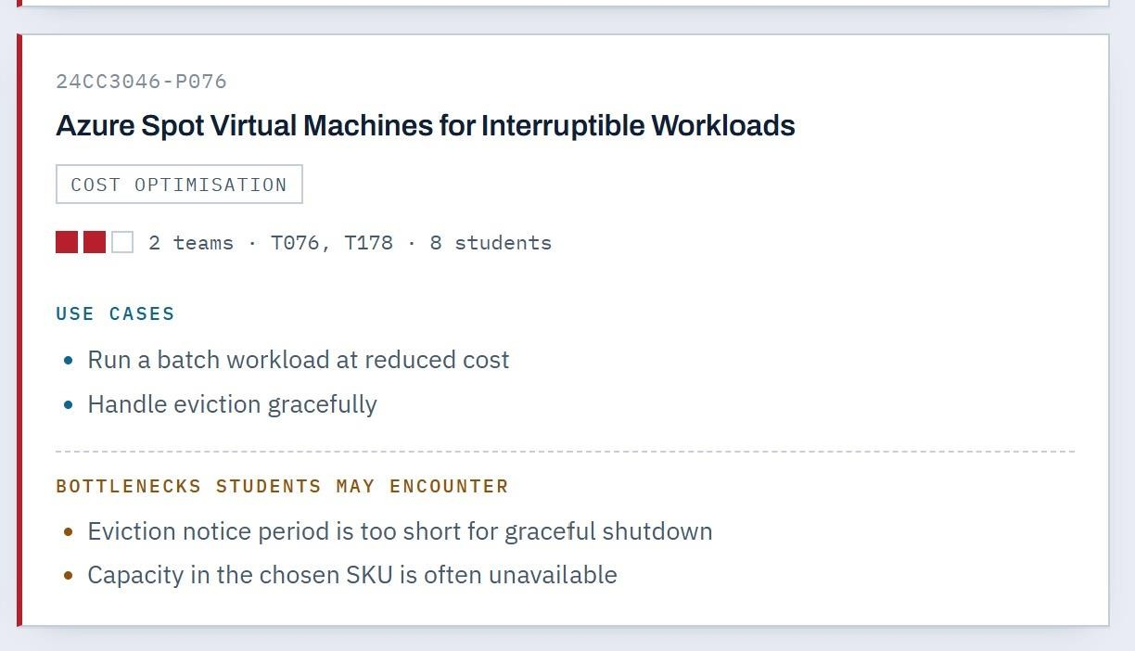
Project Overview

Azure Spot Virtual Machines are discounted Azure compute resources intended for workloads that can tolerate interruption. They are particularly useful when the main goal is to reduce infrastructure cost while accepting that compute capacity may not always be available.

Problem Statement

Cloud computing provides flexible access to computing resources, but running large-scale or non-critical workloads on standard virtual machines can become expensive. Many workloads such as batch processing, data analysis, simulations, testing, rendering, and background jobs do not require continuous access to a virtual machine. For these workloads, Azure Spot Virtual Machines can provide significant cost savings by using unused Azure compute capacity at a discounted price.
The main problem is that Spot Virtual Machines are interruptible. Azure can evict a Spot VM when the capacity is needed elsewhere, and the available capacity or VM

size may change. Therefore, a workload that assumes uninterrupted execution may fail, lose progress, or require manual intervention.
The project therefore focuses on designing and demonstrating a cost-optimized solution in which interruptible workloads are deliberately selected for Spot VMs and are designed to tolerate eviction. The system should detect or handle eviction events, save progress before shutdown where possible, restart or reschedule failed work, and use suitable VM sizes or regions when the preferred capacity is unavailable

Core Use Cases

  - Batch Processing at Reduced Cost

Large batch jobs can be divided into smaller independent tasks and executed on Spot VMs. Examples include processing thousands of files, image/video rendering, log processing, report generation, data transformation, and offline analytics. Because these jobs are often non-interactive and can be restarted, they are suitable for discounted interruptible capacity.
  - Data Analysis and ETL Workloads

Data engineering pipelines often contain tasks that process large datasets but do not need to run continuously. ETL, data cleaning, feature generation, and scheduled analytics can use Spot VMs. Checkpointing intermediate results reduces the amount of work that must be repeated after eviction.
  - Testing and Development Environments

Temporary build servers, automated test machines, performance testing, and CI/CD workloads can use Spot VMs when occasional interruption is acceptable. Failed or interrupted test jobs can be queued again without affecting production systems.
  - Scientific and Engineering Simulations

Monte Carlo simulations, parameter sweeps, scientific calculations, and engineering simulations can be split into independent jobs. If one VM is evicted, only the affected task needs to be restarted, making the overall workload resilient.
  - Media Rendering and Processing

Video rendering, image rendering, transcoding, and other compute-intensive media operations can be distributed across multiple Spot VMs. Completed output should be stored externally so that an eviction does not erase finished work.
  - Backup and Non-Critical Background Jobs

Some backup preparation, indexing, archiving, synchronization, and maintenance tasks can be scheduled on Spot VMs when they can tolerate delays and retries.

Bottlenecks and Challenges
Short Eviction Notice

The available warning period may be insufficient for a workload that needs a long graceful shutdown. Applications should checkpoint frequently and keep important state outside the VM.
Capacity Unavailability

The selected VM size, region, or SKU may not have available Spot capacity. A solution should support alternative VM sizes, regions, or capacity pools where appropriate.
Work Loss During Eviction

If progress is stored only on the local VM disk, unfinished work may need to be repeated. Frequent checkpointing and external storage reduce this risk.
Application Restart Complexity

Applications that are not designed for retries may fail when a VM disappears. Jobs should be idempotent, retryable, and divided into smaller tasks.
Cost Is Not the Only Consideration

The lowest compute price may not produce the lowest total cost if interruptions cause excessive retries or delays. The project should evaluate cost together with reliability and completion time.

Project Objectives

Demonstrate how Azure Spot VMs can reduce compute expenditure.

Identify workload characteristics that make a job suitable for interruptible infrastructure. Implement checkpointing and recovery techniques to minimize lost work.
Handle eviction and capacity-unavailability scenarios gracefully.

Measure cost, performance, interruption frequency, and workload completion. Develop a practical, fault-tolerant cloud architecture for batch workloads

Proposed Solution / Working Approach
Identify workloads that can tolerate interruption and do not require continuous availability. Create or select an Azure Spot VM with an appropriate VM size and region.
Configure the eviction policy according to the workload's recovery requirements.

Store application state, checkpoints, and completed results in durable external storage.

Divide large workloads into smaller independent tasks so that only unfinished tasks need to restart.
Monitor VM and workload status and detect eviction or capacity-related failures. Automatically retry, reschedule, or recreate interrupted tasks where possible.
Measure total cost, execution time, number of interruptions, and successful completion rate.
Compare the Spot-based approach with a standard VM approach to demonstrate cost optimization.

Abstract
This project investigates the use of Azure Spot Virtual Machines (VMs) to reduce cloud-computing costs for workloads that can tolerate interruptions. Azure Spot VMs use unused Azure capacity at a significant cost reduction, but they may be evicted when Azure needs the capacity back. The project therefore focuses on two practical use cases: running batch workloads at reduced cost and handling VM evictions gracefully.

The proposed solution evaluates an interruptible workload architecture in which jobs are designed to save progress, detect interruption events, and resume from checkpoints. The implementation can use Azure Virtual Machine Scale Sets with Spot instances, automated recovery, multiple VM sizes or regions, and appropriate eviction policies. A maximum price can also be configured when required; setting the maximum price to -1 avoids price-based eviction while still allowing capacity-based eviction. Azure documentation also notes that Spot capacity is not guaranteed, so deployment failures can occur when the selected SKU is unavailable in a region.

The project measures cost savings, workload completion time, eviction frequency, recovery time, and successful job completion. The expected result is a cost-efficient and resilient batch-processing approach that maintains acceptable performance despite interruptions. The project demonstrates that combining checkpointing, monitoring, retry logic, and flexible capacity selection can make Azure Spot VMs practical for non-critical and interruptible workloads.

